17.9: Combining Eq. (17.2) and Eq. (17.3),
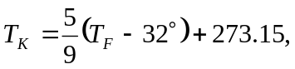
and substitution of the given Fahrenheit temperatures gives a) 216.5 K, b) 325.9 K, c) 205.4 K.

